#2925

Late 19th Century French Headboard and Bed Frame

The headboard, side and foot end support of this 19th century French bed boasts lovely blue and white needlepoint. The oak frame is beautifully carved lending an elegance to any bedroom. Circa 1880's.

H: 13"
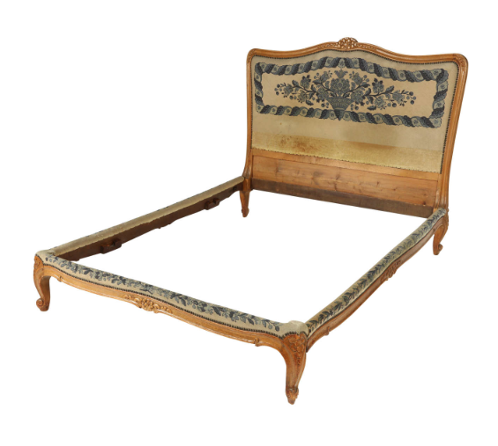
W: 4' 6"
D: 5' 2"
Frame base measures 13" from the floor.

$4,500

