#2954

Pair French Chairs

This pair of French armchairs from the first half of the 20th century are made from bleached fruitwood and are upholstered in a faux-fur tiger print.
The subtle curves of the sabre legs and scroll of the arm give these chairs an elegance that allows them to work in a range of styles from classic to contemporary.
Perfect placed in front of a desk or in an entertaining area.

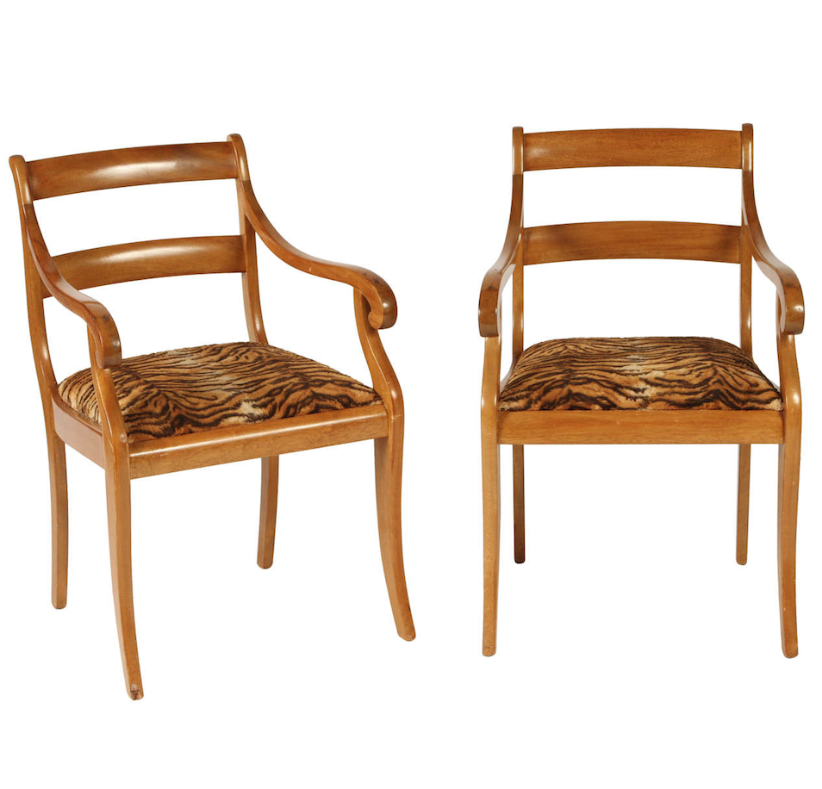
H: 33.25"
W: 22"
D: 21"
SH: 18.5"

Price: $1550

